Welcome to
Trinity Lutheran Church
Lutheran Church—Missouri Synod
Stephen Ministry Congregation

1354 South Otsego Avenue
Gaylord, Michigan 49735
Church Phone: (989) 732-4816

Church Email: secretary@trinitygaylord.com
www.trinitygaylord.com

Office Hours: Monday through Friday 9am – 1pm

OUR PURPOSE
…is to LOVE GOD, LOVE OTHERS, AND SERVE THE WORLD by worshiping the Lord Jesus, bringing our members into Christ-like maturity, and equipping them through Word and Sacrament for their mission and ministry. We go heart to heart into the world with Jesus, sharing His love, caring for one another, praying, and bringing the lost into a relationship with Christ, by the working of the Holy Spirit.

March 6, 2022
(First Sunday in Lent)
Preacher: Rev. Paul Schneider

ABOUT OUR WORSHIP
We welcome all who gather here today! We are blessed to celebrate together the mercy, grace, and love we have from God through the death and resurrection of our Lord Jesus Christ.

Children: Families with children are very welcome here. Having children in church is important so they can begin to learn about their faith in Jesus, and it’s good for the whole congregation to see. Please feel comfortable keeping “squirmy” kids in the service. This is where they belong, too!

Pew Cards: Guests and Members, please fill out the Guest/Member card located on the back of the pew in front of you and pass it to the end of the aisle. If you forget you can put it in the offering plate on your way out.

If standing is difficult: Please feel free to remain seated during any portion of the service. Please let an Elder or Usher know if you need communion in your pew seat.

About our celebration of Holy Communion: We celebrate the Lord’s Supper in the confession and glad confidence that, as he says, our Lord gives into our mouths not only bread and wine but his very body and blood to eat and to drink for the forgiveness of sins and to strengthen our union with him and with one another. Our Lord invites to his table those who trust his words, repent of all sin, and set aside any refusal to forgive and love as he forgives and loves us, that they may show forth his death until he comes.

Because those who eat and drink our Lord’s body and blood contrary to that which is stated above do so to their great harm, and also because Holy Communion is a confession of the faith which is confessed at this altar. Anyone who is not yet instructed, in doubt, or who hold a confession differing from that of the Lutheran Church—Missouri Synod, and yet desire to receive the sacrament, are asked first to speak with Pastor. Those not communing are still invited to come forward for a blessing from Pastor, and you may indicate this by crossing your arms over your chest.
TTTTTT

GREETING

P Peace be with you.
C And also with you.
T ORDER OF SERVICE T
(The liturgy is from Divine Service Setting four LSB pg. 203ff)

OPENING HYMN
"O Lord throughout These Forty Days" LSB 418 (to the tune of 437)
1 O Lord, throughout these forty days
You prayed and kept the fast;
Inspire repentance for our sin,
And free us from our past.

2 You strove with Satan, and You won;
Your faithfulness endured;
Lend us Your nerve, Your skill and trust
In God’s eternal Word.

3 Though parched and hungry, yet You prayed
And fixed Your mind above;
So teach us to deny ourselves,
Since we have known God’s love.

4 Be with us through this season, Lord,
And all our earthly days,
That when the final Easter dawns,
We join in heaven’s praise.

Text: based on Claudia F. Hernaman, 1838–98; para. Gilbert E. Doan, 1930
Text: © 1978 Lutheran Book of Worship. Used by permission: LSB Hymn License no. 110002537

Please stand as able

CONFESSION and ABSOLUTION

The sign of the cross may be made by all in remembrance of their Baptism.

P In the name of the Father and of the T Son and of the Holy Spirit.
C Amen.
P Our help is in the name of the Lord,
C who made heaven and earth.
P If You, O Lord, kept a record of sins, O Lord, who could stand?
C But with You there is forgiveness; therefore, You are feared.
P Since we are gathered to hear God’s Word, call upon Him in prayer and praise, and receive the body and blood of our Lord Jesus Christ in the fellowship of this altar, let us first consider our unworthiness and confess before God and one another that we have sinned in thought, word, and deed, and that we cannot free ourselves from our sinful condition. Together as His people let us take refuge in the infinite mercy of God, our heavenly Father, seeking His grace for the sake of Christ, and saying: God, be merciful to me, a sinner.
C Almighty God, have mercy upon us, forgive us our sins, and lead us to everlasting life. Amen.
P Almighty God in His mercy has given His Son to die for you and for His sake forgives you all your sins. As a called and ordained servant of Christ, and by His authority, I therefore forgive you all your sins in the name of the Father and of the T Son and of the Holy Spirit.
C Amen.

SERVICE OF THE WORD
INTROIT Psalm 119:1–2, 4–5; antiphon: v. 7

P When he calls to me, I will answer him; I will be with him in trouble;
I will rescue him and honor him.
C With long life I will satisfy him
and show him my salvation.
P Because you have made the Lord your dwelling place—
the Most High, who is my refuge—
C no evil shall be allowed to befall you,
no plague come near your tent.
P For he will command his angels concerning you
to guard you in all your ways.
C On their hands they will bear you up,
lest you strike your foot against a stone.
P You will tread on the lion and the adder;
the young lion and the serpent you will trample underfoot.
A Glory be to the Father and to the Son
and to the Holy Spirit;
as it was in the beginning,
is now, and will be forever. Amen.
P When he calls to me, I will answer him; I will be with him in trouble;
I will rescue him and honor him.
C With long life I will satisfy him
and show him my salvation.

KYRIE LSB 204
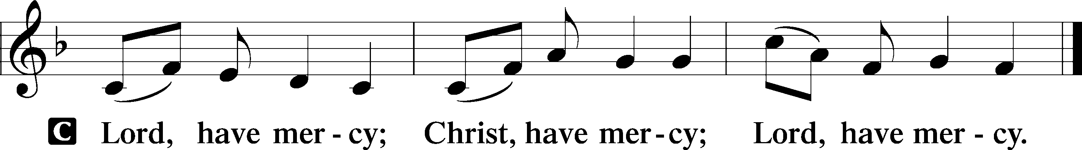

SALUTATION AND COLLECT OF THE DAY

P The Lord be with you.
C And also with you.

P Let us pray.
O Lord God, You led Your ancient people through the wilderness and brought them to the promised land. Guide the people of Your Church that following our Savior we may walk through the wilderness of this world toward the glory of the world to come; through Jesus Christ, Your Son, our Lord, who lives and reigns with You and the Holy Spirit, one God, now and forever.
C Amen

Please be seated

OLD TESTAMENT READING Deuteronomy 26:1–11
¹“When you come into the land that the Lord your God is giving you for an inheritance and have taken possession of it and live in it, ²you shall take some of the first of all the fruit of the ground, which you harvest from your land that the Lord your God is giving you, and you shall put it in a basket, and you shall go to the place that the Lord your God will choose, to make his name to dwell there. ³And you shall go to the priest who is in office at that time and say to him, ‘I declare today to the Lord your God that I have come into the land that the Lord swore to our fathers to give us.’ ⁴Then the priest shall take the basket from your hand and set it down before the altar of the Lord your God.
⁵“And you shall make response before the Lord your God, ‘A wandering Aramean was my father. And he went down into Egypt and sojourned there, few in number, and there he became a nation, great, mighty, and populous. ⁶And the Egyptians treated us harshly and humiliated us and laid on us hard labor. ⁷Then we cried to the Lord, the God of our fathers, and the Lord heard our voice and saw our affliction, our toil, and our oppression. ⁸And the Lord brought us out of Egypt with a mighty hand and an outstretched arm, with great deeds of terror, with signs and wonders. ⁹And he brought us into this place and gave us this land, a land flowing with milk and honey. ¹⁰And behold, now I bring the first of the fruit of the ground, which you, O Lord, have given me.’ And you shall set it down before the Lord your God and worship before the Lord your God. ¹¹And you shall rejoice in all the good that the Lord your God has given to you and to your house, you, and the Levite, and the sojourner who is among you.”

P This is the Word of the Lord.
C Thanks be to God.

Please stand as able

CHOIR “In Christ Alone”

EPISTLE: Romans 10:8b–13
“The word is near you, in your mouth and in your heart” (that is, the word of faith that we proclaim); ⁹because, if you confess with your mouth that Jesus is Lord and believe in your heart that God raised him from the dead, you will be saved. ¹⁰For with the heart one believes and is justified, and with the mouth one confesses and is saved. ¹¹For the Scripture says, “Everyone who believes in him will not be put to shame.” ¹²For there is no distinction between Jew and Greek; the same Lord is Lord of all, bestowing his riches on all who call on him. ¹³For “everyone who calls on the name of the Lord will be saved.”

P This is the Word of the Lord.
C Thanks be to God.

HOLY GOSPEL Luke 4:1–13
P The Holy Gospel according to St. Luke, the fourth chapter.
C Glory to You, O Lord.

¹Jesus, full of the Holy Spirit, returned from the Jordan and was led by the Spirit in the wilderness ²for forty days, being tempted by the devil. And he ate nothing during those days. And when they were ended, he was hungry. ³The devil said to him, “If you are the Son of God, command this stone to become bread.” ⁴And Jesus answered him, “It is written, ‘Man shall not live by bread alone.’” ⁵And the devil took him up and showed him all the kingdoms of the world in a moment of time, ⁶and said to him, “To you I will give all this authority and their glory, for it has been delivered to me, and I give it to whom I will. ⁷If you, then, will worship me, it will all be yours.” ⁸And Jesus answered him, “It is written,
“‘You shall worship the Lord your God,
and him only shall you serve.’”
⁹And he took him to Jerusalem and set him on the pinnacle of the temple and said to him, “If you are the Son of God, throw yourself down from here, ¹⁰for it is written,
“‘He will command his angels concerning you,
to guard you,’
¹¹and
“‘On their hands they will bear you up,
lest you strike your foot against a stone.’”
¹²And Jesus answered him, “It is said, ‘You shall not put the Lord your God to the test.’” ¹³And when the devil had ended every temptation, he departed from him until an opportune time.

P This is the Gospel of the Lord.
C Praise to You, O Christ.

NICENE CREED
C I believe in one God,
the Father Almighty,
maker of heaven and earth
and of all things visible and invisible.
And in one Lord Jesus Christ,
the only-begotten Son of God,
begotten of His Father before all worlds,
God of God, Light of Light,
very God of very God,
begotten, not made,
being of one substance with the Father,
by whom all things were made;
who for us men and for our salvation came down from heaven
and was incarnate by the Holy Spirit of the virgin Mary
and was made man;
and was crucified also for us under Pontius Pilate.
He suffered and was buried.
And the third day He rose again according to the Scriptures
and ascended into heaven
and sits at the right hand of the Father.
And He will come again with glory to judge both the living and the dead,
whose kingdom will have no end.
And I believe in the Holy Spirit,
the Lord and giver of life,
who proceeds from the Father and the Son,
who with the Father and the Son together is worshiped and glorified,
who spoke by the prophets.
And I believe in one holy Christian and apostolic Church,
I acknowledge one Baptism for the remission of sins,
and I look for the resurrection of the dead
and the life T of the world to come. Amen.

Please be seated

ALL GOD’S CHILDREN – TALK

PRE-SERMON HYMN
Spread the Reign of God the Lord LSB 830 sts. 1–4
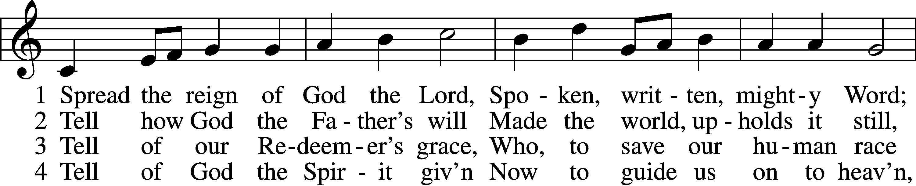
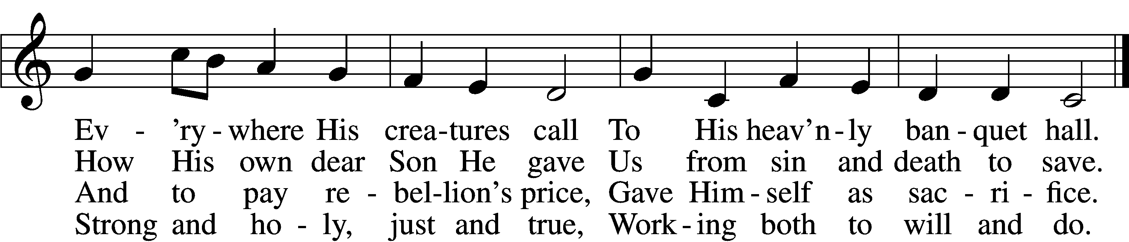
Text: Jonathan Friedrich Bahnmaier, 1774–1841; tr. composite
Tune: Geist-reiches Gesang-Buch, 1704, Halle, ed. Johann A. Freylinghausen, alt.
Text and tune: Public domain

SERMON
POST-SERMON HYMN
830 Spread the Reign of God the Lord LSB 830 sts. 5–6
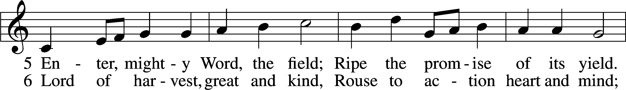
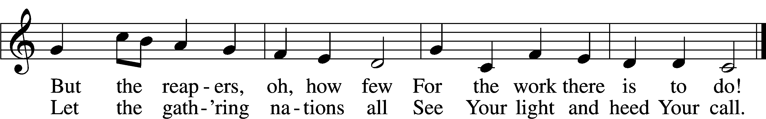
Text: Jonathan Friedrich Bahnmaier, 1774–1841; tr. composite
Tune: Geist-reiches Gesang-Buch, 1704, Halle, ed. Johann A. Freylinghausen, alt.
Text and tune: Public domain

ALL GOD’S CHILDREN- TALK

Please stand as able

PRAYER of the CHURCH
After each Segment:
P Lord, in Your Mercy,
C Hear our Prayer.
After Final Segment:
P Hear us as we pray in His name and as He has taught us:
LORD’S PRAYER
C Our Father who art in heaven,
hallowed be Thy name,
Thy kingdom come,
Thy will be done on earth
as it is in heaven;
give us this day our daily bread;
and forgive us our trespasses
as we forgive those
who trespass against us;
and lead us not into temptation,
but deliver us from evil.
For Thine is the kingdom
and the power and the glory
forever and ever. Amen.

SERVICE of the SACRAMENT

PREFACE LSB 208
P The Lord be with you.
C And also with you.
P Lift up your hearts.
C We lift them to the Lord.
P Let us give thanks to the Lord our God.
C It is right to give Him thanks and praise.
P It is truly good, right, and salutary that we should at all times and in all places give thanks to You, O Lord, holy Father, almighty and everlasting God, for the countless blessings You so freely bestow on us and all creation. Above all, we give thanks for Your boundless love shown to us when You sent Your only-begotten Son, Jesus Christ, into our flesh and laid on Him our sin, giving Him into death that we might not die eternally. Because He is now risen from the dead and lives and reigns to all eternity, all who believe in Him will overcome sin and death and will rise again to new life. Therefore with angels and archangels and with all the company of heaven we laud and magnify Your glorious name, evermore praising You and singing:

SANCTUS LSB 208
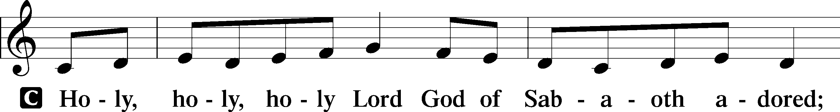
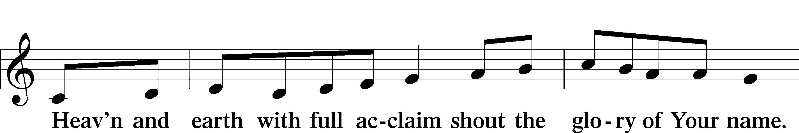
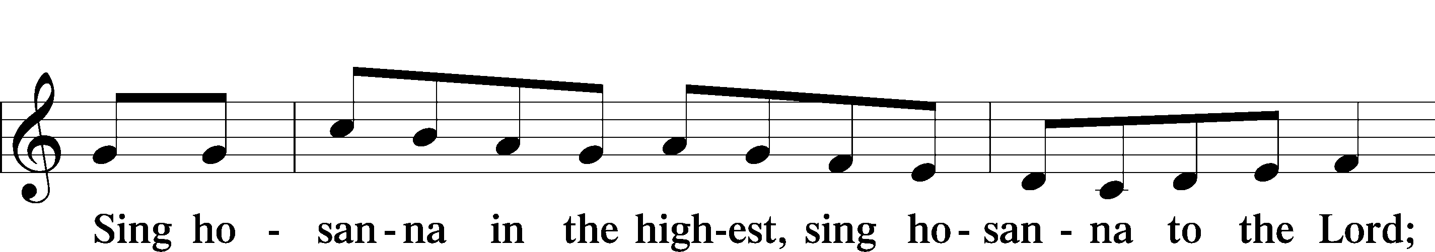

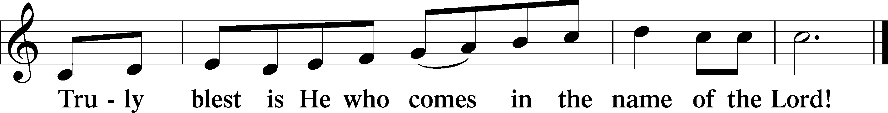

THE WORDS OF OUR LORD
P Our Lord Jesus Christ, on the night when He was betrayed, took bread, and when He had given thanks, He broke it and gave it to the disciples and said: “Take, eat; this is My T body, which is given for you. This do in remembrance of Me.”
In the same way also, He took the cup after supper, and when He had given thanks, He gave it to them, saying: “Drink of it, all of you; this cup is the New Testament in My T blood, which is shed for you for the forgiveness of sins. This do, as often as you drink it, in remembrance of Me.”

PAX DOMINI
P The peace of the Lord be with you always.
C Amen.

AGNUS DEI
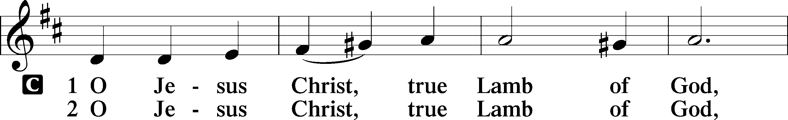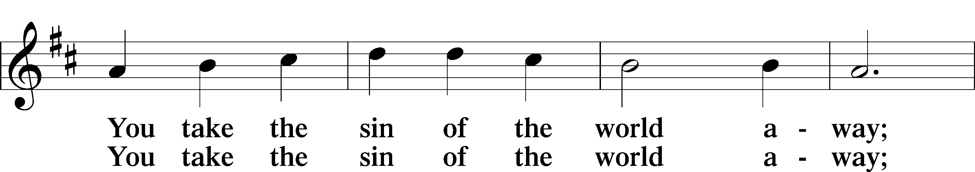
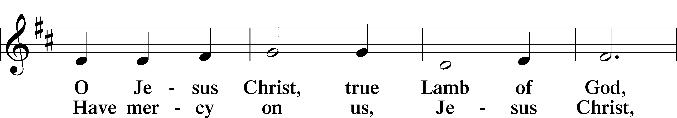
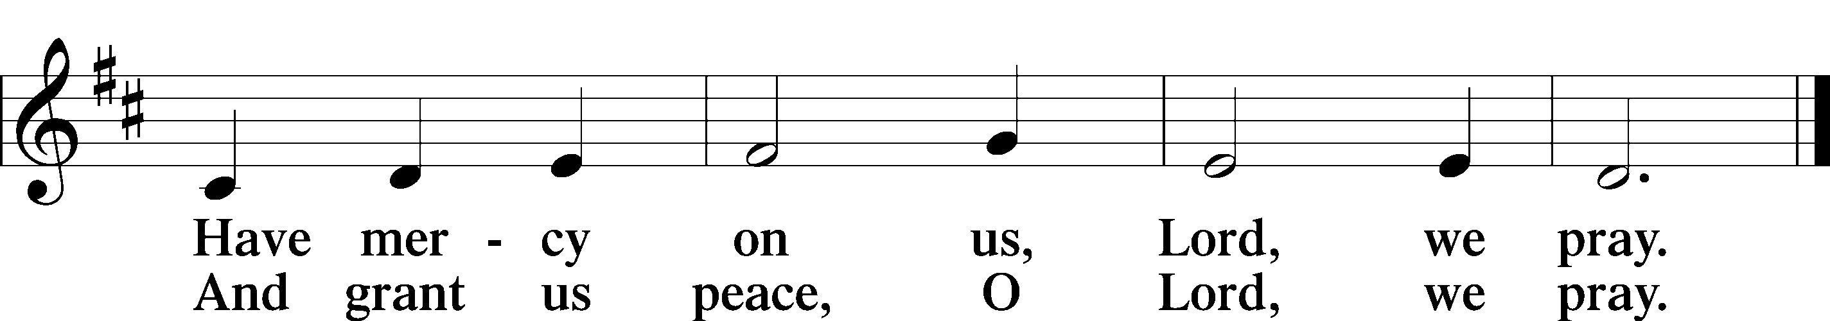

Please be seated

DISTRIBUTION
The pastor and those who assist him receive the body and blood of Christ first, then Communion will be served in a continuous fashion. Households may commune at the same time together. Ushers will help direct you forward via the center aisle; please return to your seats via the side aisles. Gluten-free bread is available for those who need it, as is non-alcoholic grape juice. Simply request either when you come forward to receive Communion.

DISTRIBUTION HYMN
Jesus Comes Today with Healing LSB 620
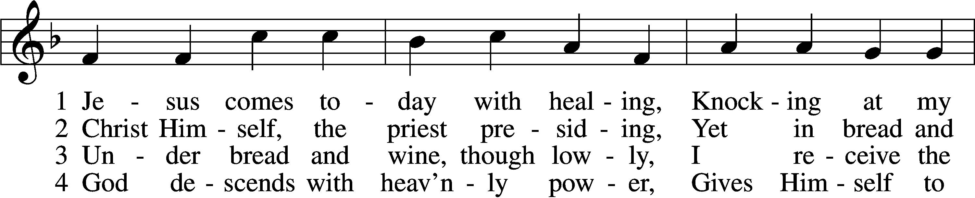
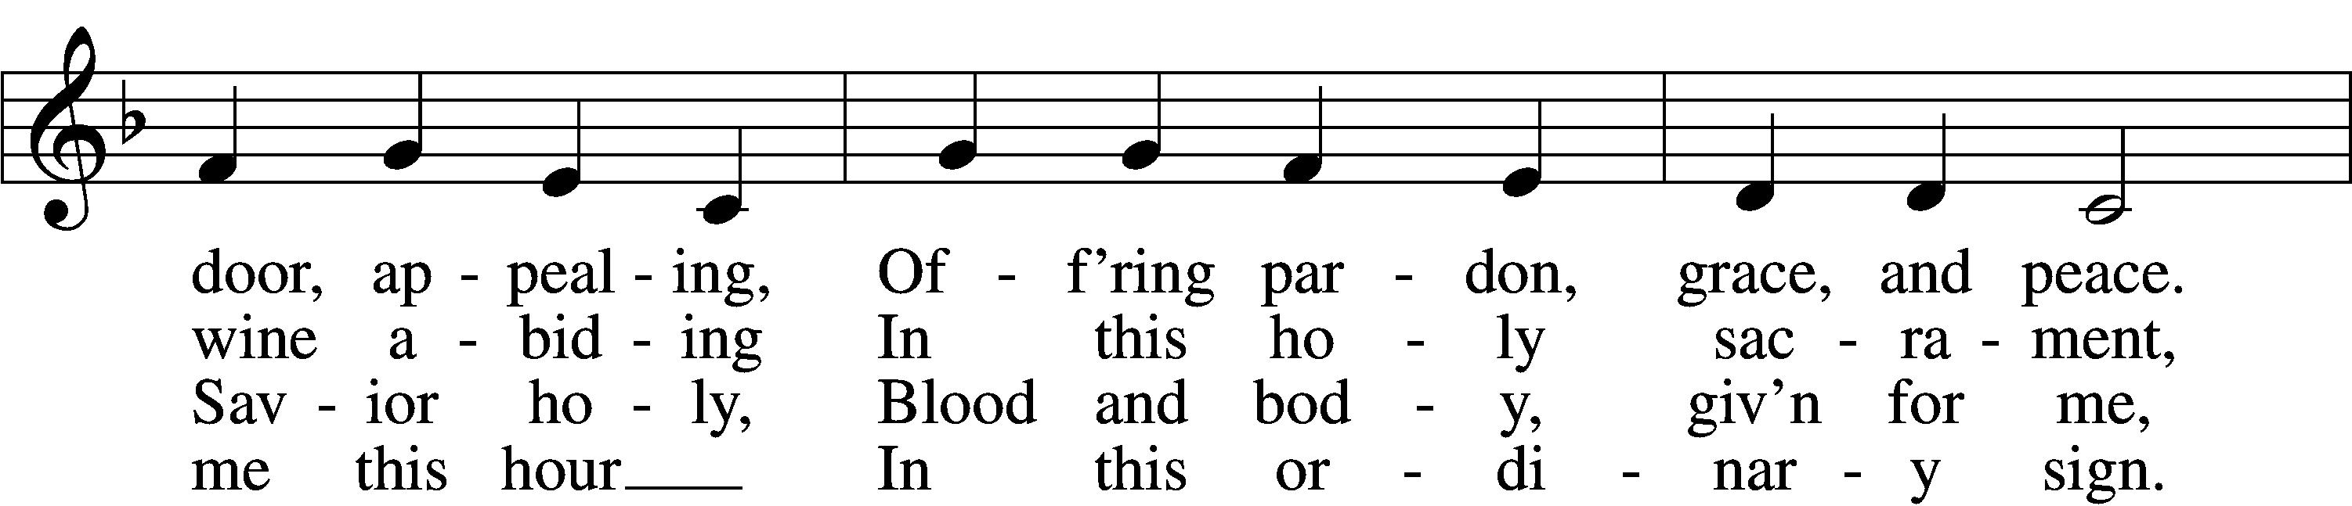
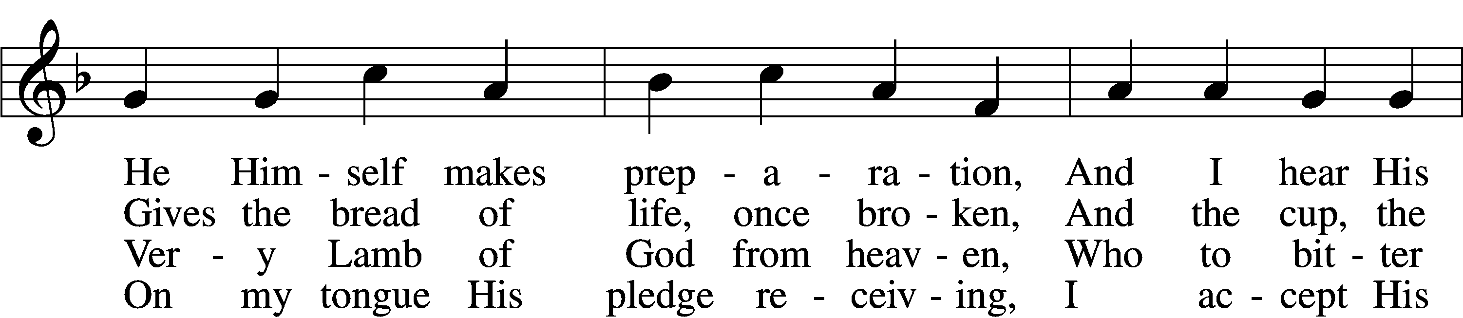
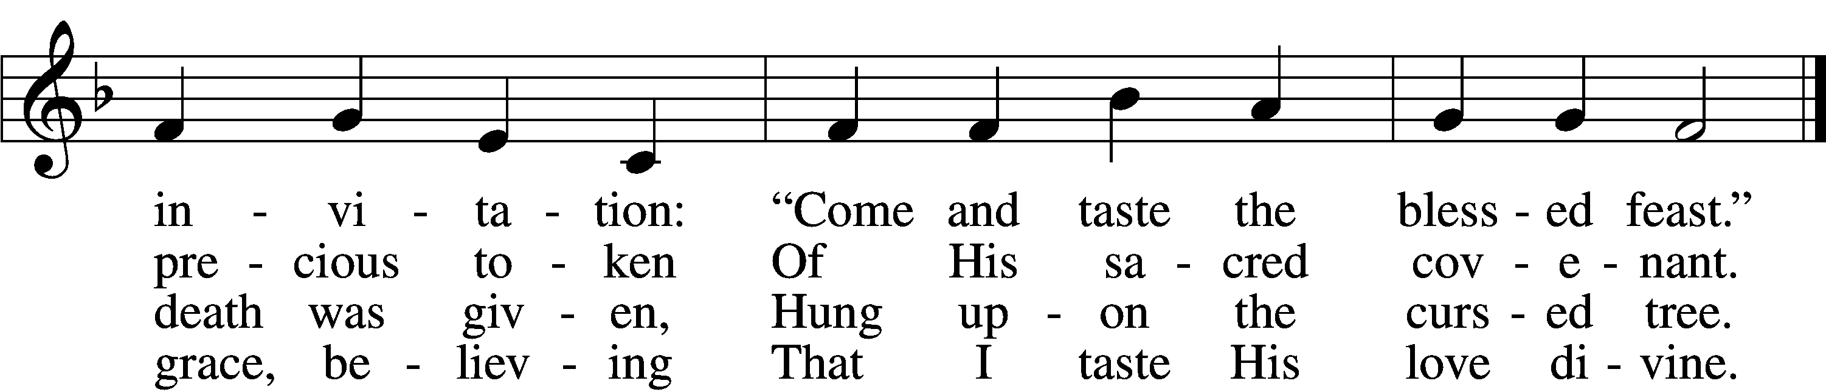

5 Let me praise God’s boundless favor,
Whose own feast of love I savor,
Bidden by His gracious call.
Wedding garments He provides me,
With a robe of white He hides me,
Fits me for the royal hall.
Text: Heinrich Puchta, 1808–58; tr. David W. Rogner, 1960
Tune: Johann Löhner, 1645–1705; adapt. Johann Balthasar König, 1691–1758Text: © David W. Rogner. Used by permission: LSB Hymn License no. 110002537 Tune: Public domain

6 Now have I found consolation,
Comfort in my tribulation,
Balm to heal the troubled soul.
God, my shield from ev’ry terror,
Cleanses me from sin and error,
Makes my wounded spirit whole.

Please stand as able

THE DISMISSAL
P The body and blood of our Lord Jesus Christ strengthen and preserve you in body and soul
to life everlasting. Depart T in peace.
C Amen.

NUNC DIMITTIS LSB 211
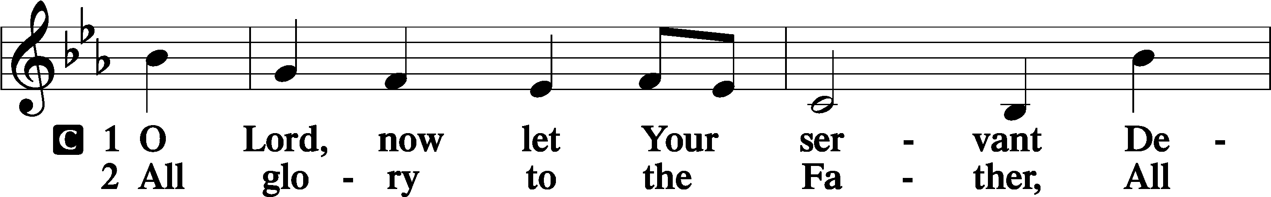
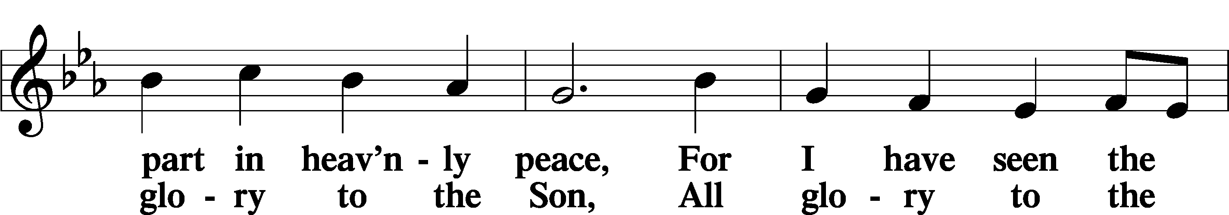
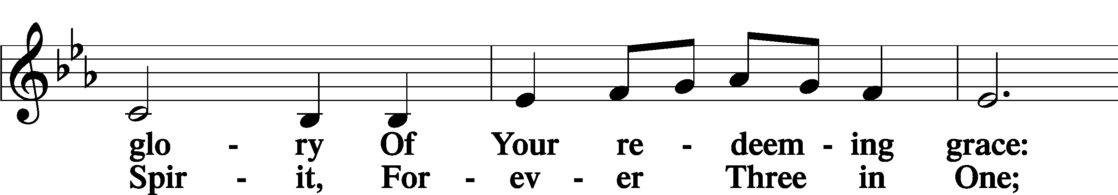
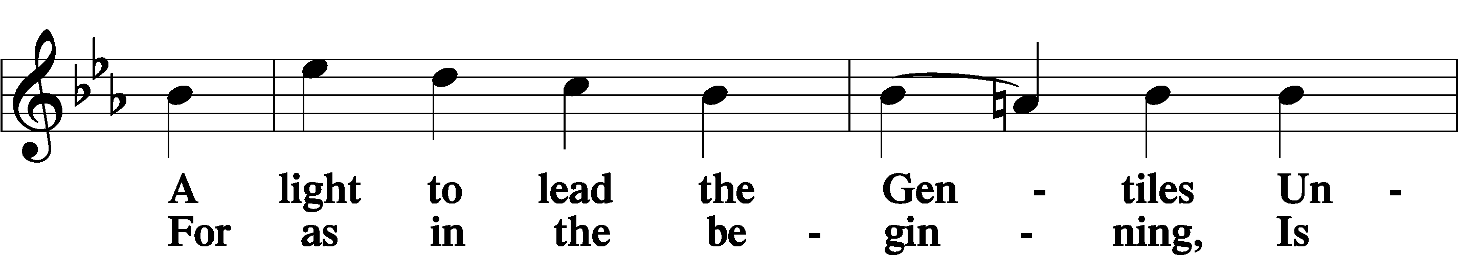
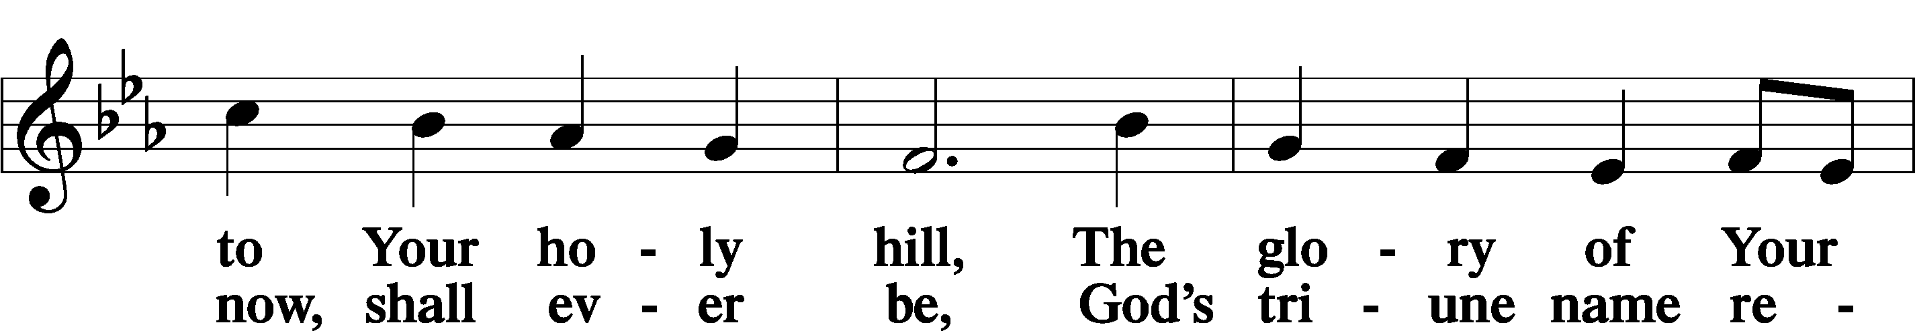
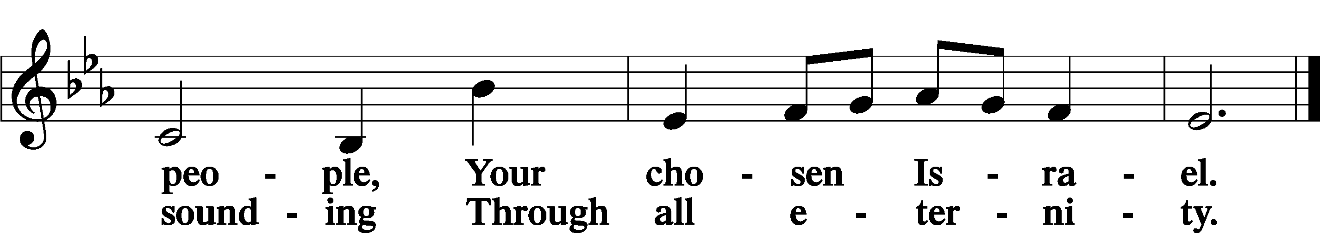

POST COMMUNION COLLECT
P Let us pray.
O God the Father, the fountain and source of all goodness, who in loving-kindness sent Your only-begotten Son into the flesh, we thank You that for His sake You have given us pardon and peace in this Sacrament, and we ask You not to forsake Your children but always to rule our hearts and minds by Your Holy Spirit that we may be enabled constantly to serve You; through Jesus Christ, Your Son, our Lord, who lives and reigns with You and the Holy Spirit, one God, now and forever.
C Amen.

BENEDICAMUS LSB 212
P Let us bless the Lord.
C Thanks be to God.
BENEDICTION
P The Lord bless you and keep you.
The Lord make His face shine on you and be gracious to you.
The Lord look upon you with favor and T give you peace.
C Amen.

Please be seated
CLOSING HYMN
All Depends on Our Possessing LSB 732 sts. 1-3,5
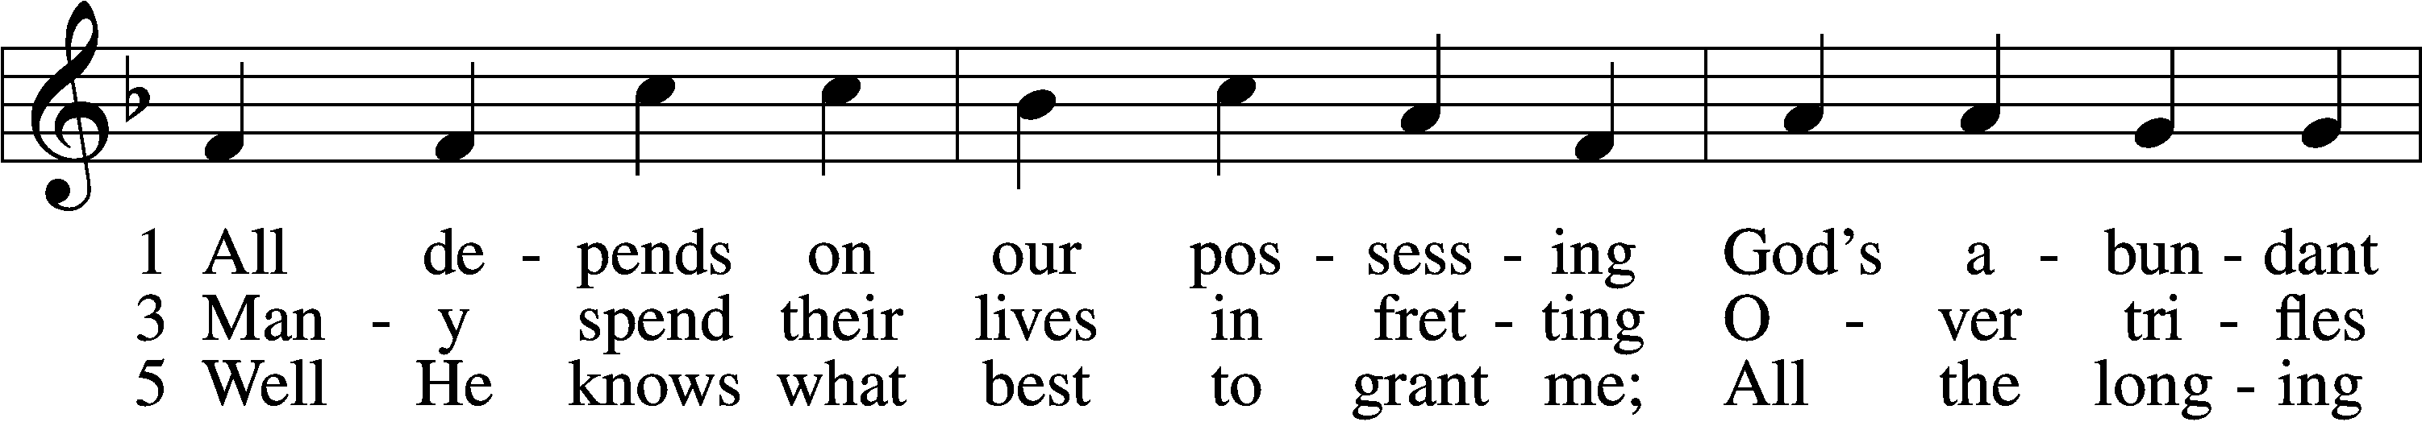
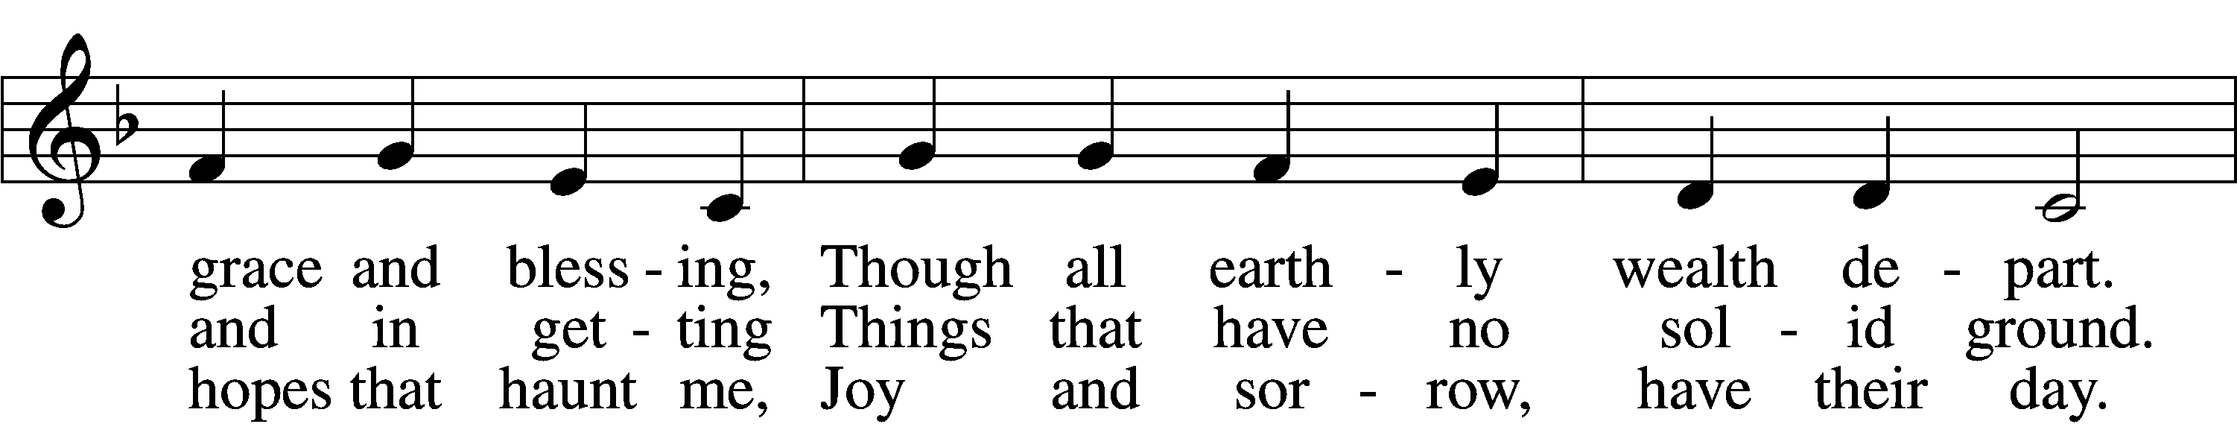
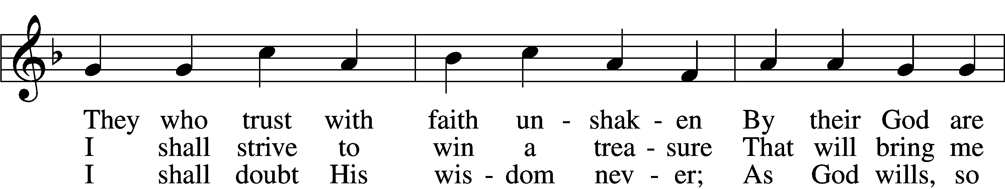
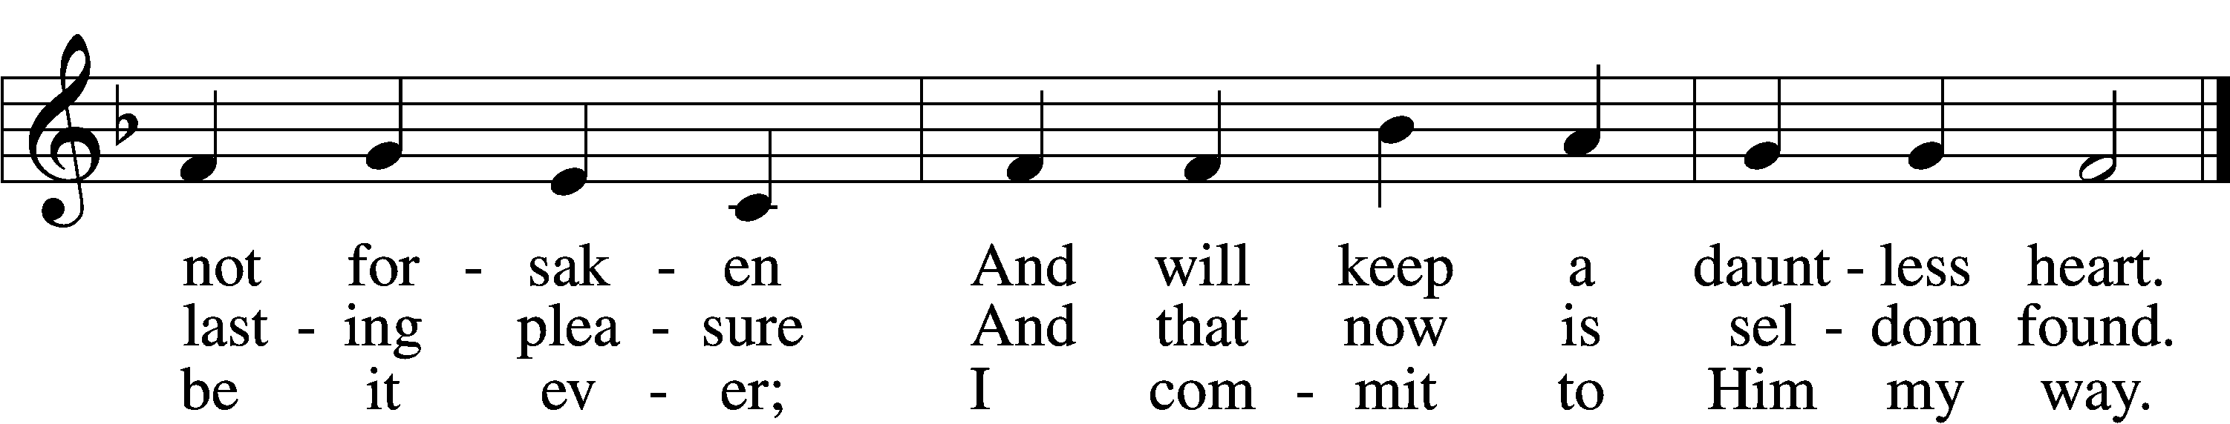
Text: Andächtige Haus-Kirche, 1676, Nürnberg; tr. Catherine Winkworth, 1827–78, alt.
Tune: Johann Löhner, 1645–1705; adapt. Johann Balthasar König, 1691–1758
Text and tune: Public domain

ANNOUNCEMENTS and SENDING WORDS
P We go to live for Jesus!
C We go to share His love!

Acknowledgments
Unless otherwise indicated, Scripture quotations are from the ESV® Bible (The Holy Bible, English Standard Version®), copyright © 2001 by Crossway, a publishing ministry of Good News Publishers. Used by permission. All rights reserved. Created by Lutheran Service Builde

Next Week’s Readings
Old Testament: Jeremiah 26:8-15
Epistle: Philippians 3:17-4:1
Holy Gospel: Luke 13:31-35

SERVING in GODS HOUSE TODAY
Pastor: Rev. Paul Schneider
Elder: Wally Beasinger, Gene Seibel
Ushers: Bill & Terry Stiles
Greeters: Larry & Joann Whitney
Coffee
Counters: Leslie Martin, Kathy Erat
Altar Care: Karen Schneider
Virtual Organist: Bob Erat
Children’s Talk: Nancy Ely

PRAYERS
Please contact the office with updates to the prayer list. People will remain on the prayer list for 4 weeks before being removed. If they need to remain on the list, please keep Elaine informed and of any updates. This will help us to have a more accurate list. Thanks for your cooperation.

Those who continue to grieve the passing of loved ones, Family of June Weber
Those with upcoming surgery:
Those recovering from surgery: Elaine Raschke, Jennifer Martin
Those with health concerns: Tiffany Amsdill, Laurie Breen, Hope Buchinger, Jennifer Martin, Leslie Martin, Kay Gregg, Hilda Koch, Eleanor Raether, Beth Smith, and John and Judi Stutzman.
Those diagnosed with cancer: Leah Eicher, Rachel Frisch, Joe Gibson, Hope Osantowski, and Maria Freimark
Those under Hospice Home Care: Ruth Luebs, and Ken Williamson.

BIRTHDAYS: ANNIVERSARIES;
3/7 Teri Osantowski 3/12 Richard & Susan Straith
3/11 Adrienne Edwards

MESSAGES

MEMBER & GUEST CARDS: If you have not filled out a member/guest card, please take the time to fill one out and place it in the plate behind the back pews in our sanctuary.

WEDNESDAY MORNING BIBLE STUDY, 10:00am in the fellowship hall with Pastor Ken Bernthal.

GREETING CARDS If you are in need of some greeting cards, we carry an array of them in the cabinet in the library. The cost of the cards is posted on the cabinet. The money collected from the cards goes to LWML to help support Missions.

CANCER and FRIENDS SUPPORT GROUP: Will be meeting in March 22nd. We will be having a guest speaker. Please remember Cancer & Friends Support Group is not just for people going through treatment, or survivors, we are also here for caregiver, spouse, children, and friends. There are times when we can all use someone to talk to during those difficult times. If there is any subject you would like to discuss with me you call or text or at 989-350-4391. Hope you will join us.

KUT-UPS will be meeting Monday March 7th at 10am in the fellowship hall.
.

THIS WEEK AT TRINITY
March 6 Sunday
9:00 am Worship Service - Holy Communion – Rev. Paul Schneider
10:00 am Fellowship & Coffee Hour
10:30 am Sunday Morning Bible Study W/ Dr. Tom Beach

March 7 Monday
10:00 am Kut-Ups -Fellowship Hall
7:00 pm Choir

March 8 Tuesday
6:30 pm Church Council Meeting (Fellowship Hall)

March 9 Wednesday
10:00 am Wednesday Morning Bible Study W/ Pastor Ken Bernthal

March 10 Thursday

March 11 Friday

March 12 Saturday

March 13 Sunday
9:00 am Worship Service - Holy Communion – Rev. Ken Bernthal
10:00 am Fellowship & Coffee Hour
10:30 am Bible Study with Dr. Tom Beach (Tutoring Room)

